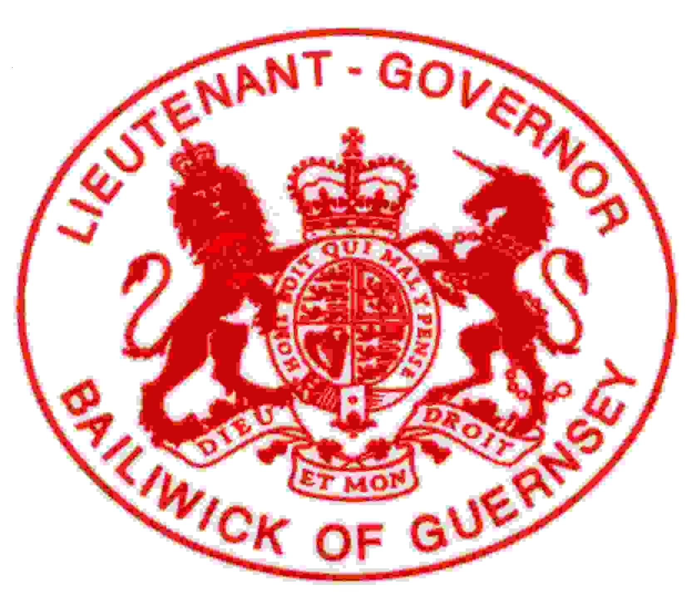

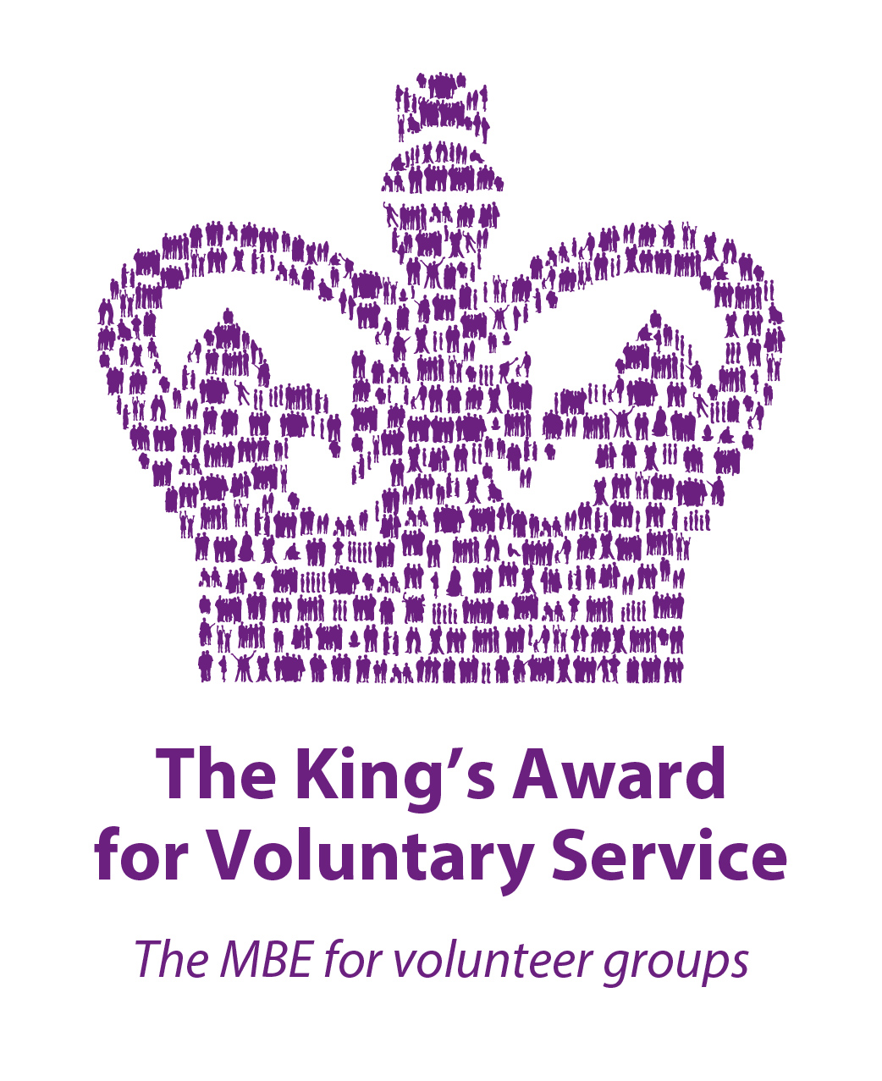

**News Release 26th September 2024**

**CELEBRATE OUTSTANDING VOLUNTEERS WITH THE FIRST KING’S AWARD**

ISLANDERS have an opportunity to nominate exceptional local charities to be the first to receive a prestigious award from His Majesty The King.

The King’s Award for Voluntary Service is equivalent to the MBE and the highest national recognition for voluntary organisations. A total of 30 Bailiwick charities have been recognised with The Queen’s Award for Voluntary Service since it was first granted in 2003 (see notes 1 & 2). The next successful local organisation will be the first to receive the award during the reign of His Majesty King Charles III.

Guernsey’s Lieutenant-Governor, Lieutenant General Richard Cripwell, commented: ‘The King’s Awards for Voluntary Service is the highest award for volunteer-led organisations, which not only rewards excellence but also fosters the very best working practices throughout the third sector. It represents the gold standard of volunteering and any group that receives it can be very proud indeed.’

His Excellency paid tribute to Bailiwick charities: ‘The local voluntary sector touches the lives of so many, both within our islands and beyond. It’s built on a spirit of volunteering that is central to our communities and delivers so many valuable services. This is an opportunity to recognise those groups that are not only fulfilling that role, but also meeting the very highest standards.’

It is 10 years since nominations for the Award have been made directly by members of the public. Any group of three or more people doing volunteering work can be nominated for the King’s Award for Voluntary Service. The group must be led by volunteers, rather than paid staff, and provide a specific and direct benefit to its local community. It should have been running for at least three years, with more than half of the people involved having the right to live in the UK or one of the Crown Dependencies (see note 3).

More:///

For full details on The King’s Award for Voluntary Service and to nominate a group, visit [www.gov.uk/kings-award-for-voluntary-service](http://www.gov.uk/kings-award-for-voluntary-service) and follow the links. Nominations for the 2025 Awards must be submitted by 1st December 2024. The Awards are announced annually on The King’s Birthday, 14th November.

**~ Ends ~**

For more information contact Marco Ciotti, Tel. 01481 226666, email [marco.ciotti@gov.gg](mailto:marco.ciotti@gov.gg)

**PICTURE:** Mrs Philippa Stahelin receiving The Queen’s Award for Voluntary Service from the Lieutenant-Governor in 2019 on behalf of Headway Guernsey.

**Notes for Editors:**

1. The Bailiwick QAVS roll of honour:

|  |  |  |
| --- | --- | --- |
|  | **Year** | **Name of Organisation** |
|  | 2002/3 | Guernsey Welfare Service; WRVS Alderney |
|  | 2003/4 | Guernsey Society for the Physically Disabled (The Ron Short Centre) |
|  | 2004/5 | Channel Islands Air Search; Guernsey Women’s Refuge |
|  | 2005/6 | Guernsey Specials Gym Club |
|  | 2006/7 | Les Bourgs Hospice; Grow Limited |
|  | 2007/8 | Guernsey Jumbulance Holidays |
|  | 2008/9 | Victim Support and Witness Service |
|  | 2009/10 | Guernsey Alzheimer’s Association; The Health Information Exchange |
|  | 2010/11 | The Guernsey Dyslexia Day Centre; The Alderney Library |
|  | 2011/12 | Wigwam Support Group; Guernsey Bereavement Service |
|  | 2013/14 | St John Care in the Community Library; The Guernsey Society for Cancer Relief; Guernsey Samaritans |
|  | 2014/15 | Priaulx Premature Baby Foundation; Alderney Cancer Relief |
|  | 2015/16 | Citizens Advice Bureau |
|  | 2016/17 | Caritas Charitable Trust LBG; Male Uprising Guernsey (MUG) |
|  | 2018/19 | Bailiwick of Guernsey Scout Association; Headway Guernsey |
|  | 2019/20 | Guernsey Disability Swimming LBG; Guernsey Voluntary Service |
|  | 2020/21 | Creative Learning in Prison; Guernsey Branch of the RNLI |

1. The award was announced by [Queen Elizabeth II](https://en.wikipedia.org/wiki/Elizabeth_II) on 30th April 2002, in celebration of Her Majesty’s Golden Jubilee and as part of Her Golden Jubilee speech to the House of Lords and House of Commons. The first awards were made in 2003. In February 2023, His Majesty King Charles III announced that He wished to continue His mother's legacy by giving His name to the awards.
2. About the Queen’s Award for Voluntary Service – TheKing’s Award for Voluntary Service not only serves to provide recognition of volunteer groups, but also demonstrates the high respect in which volunteering is held. The Award is overseen by the Department of Culture, Media and Sport (DCMS). Groups must be nominated for the Award – self nomination is not permitted. Groups solely concerned with fundraising for charitable purposes are not eligible.

**Issued by the Office of the Lieutenant-Governor,**

**Tel. 726666; Email:** [**governorsoffice@gov.gg**](mailto:governorsoffice@gov.gg)

[**www.governmenthouse.gg**](http://www.governmenthouse.gg)Follow us on Twitter [@GvHouseGuernsey](https://twitter.com/GvHouseGuernsey)